LAB Logbook
Repo

Lab 1
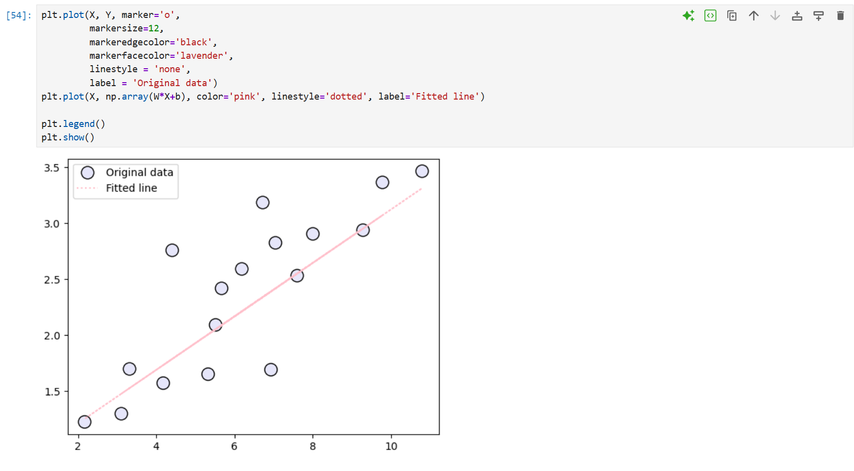
Lab 2
Task 1:

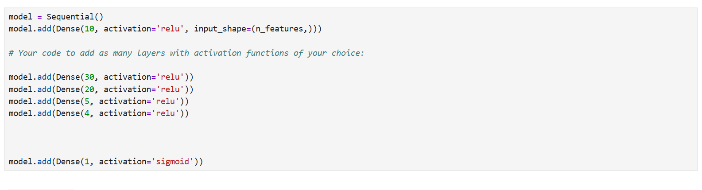

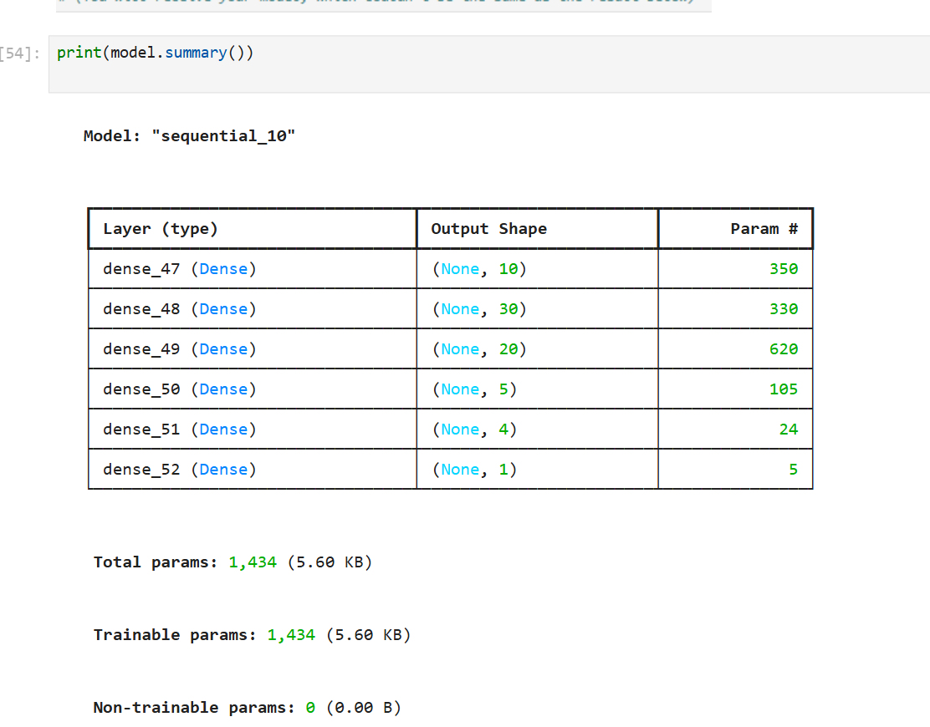

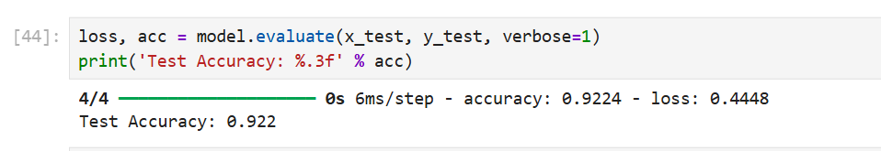

Task2:
Output1: 0.7459349536
Output2: 0.7459349536

Lab 3
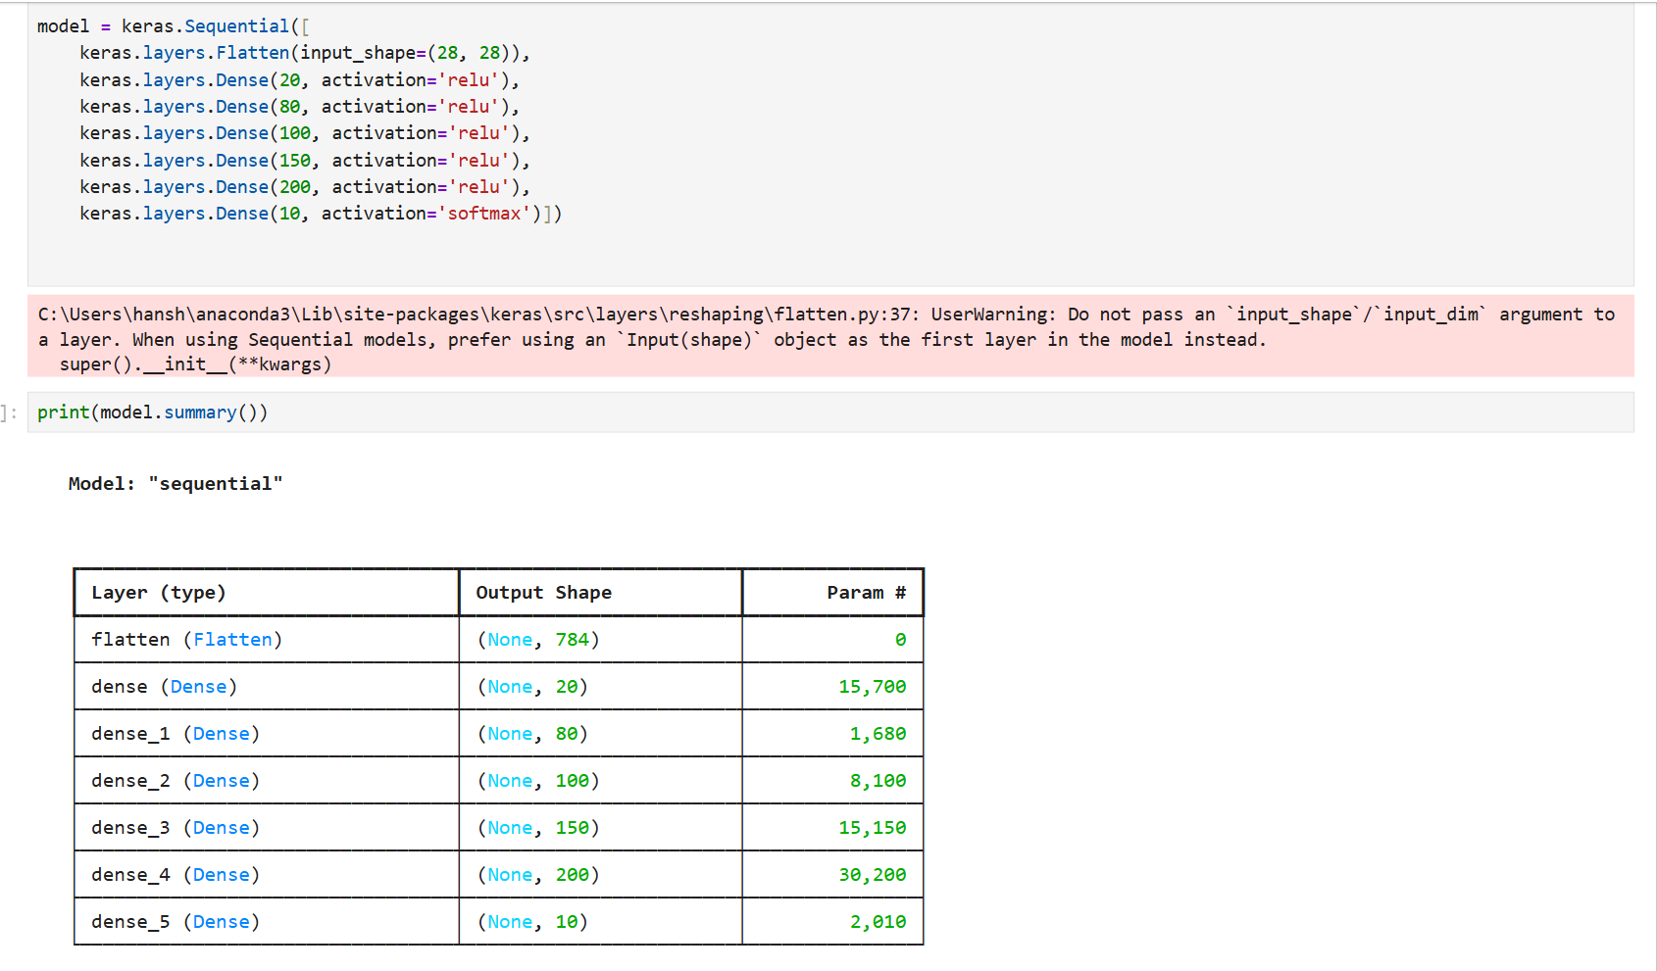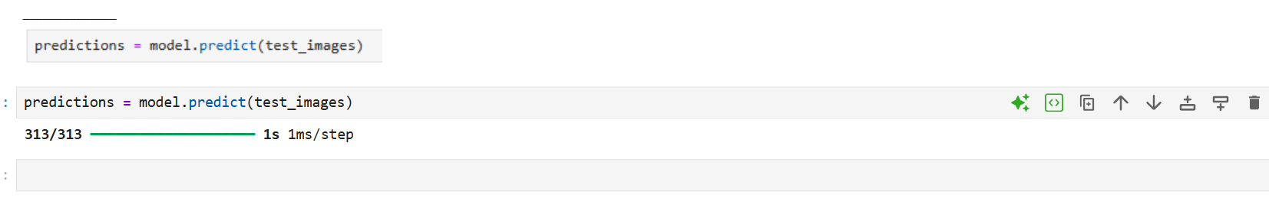

Lab 4
Task-1
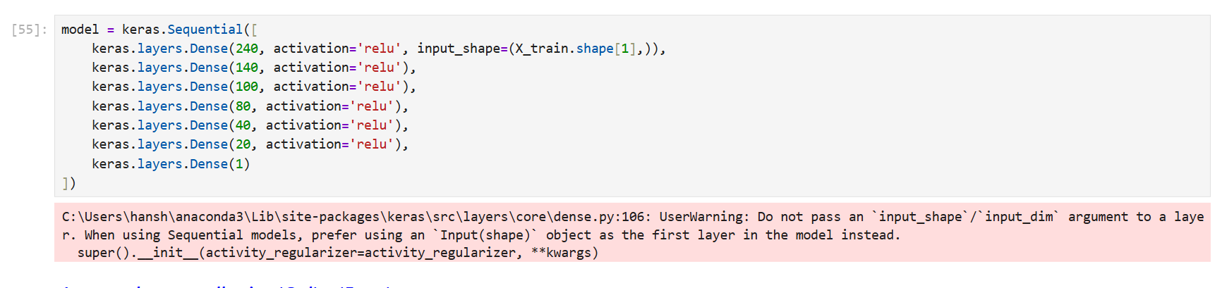
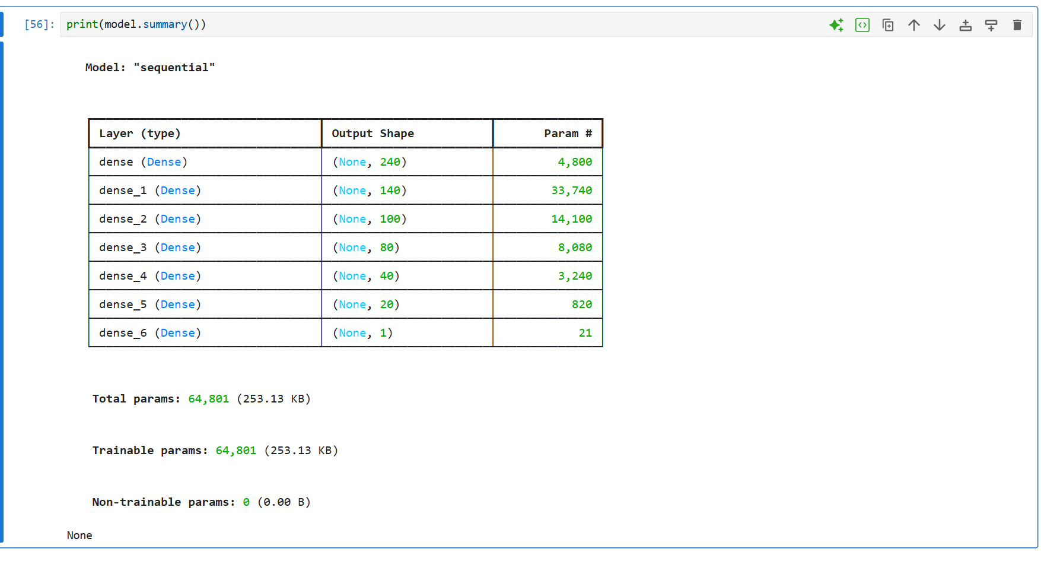
Task-2
Task-3
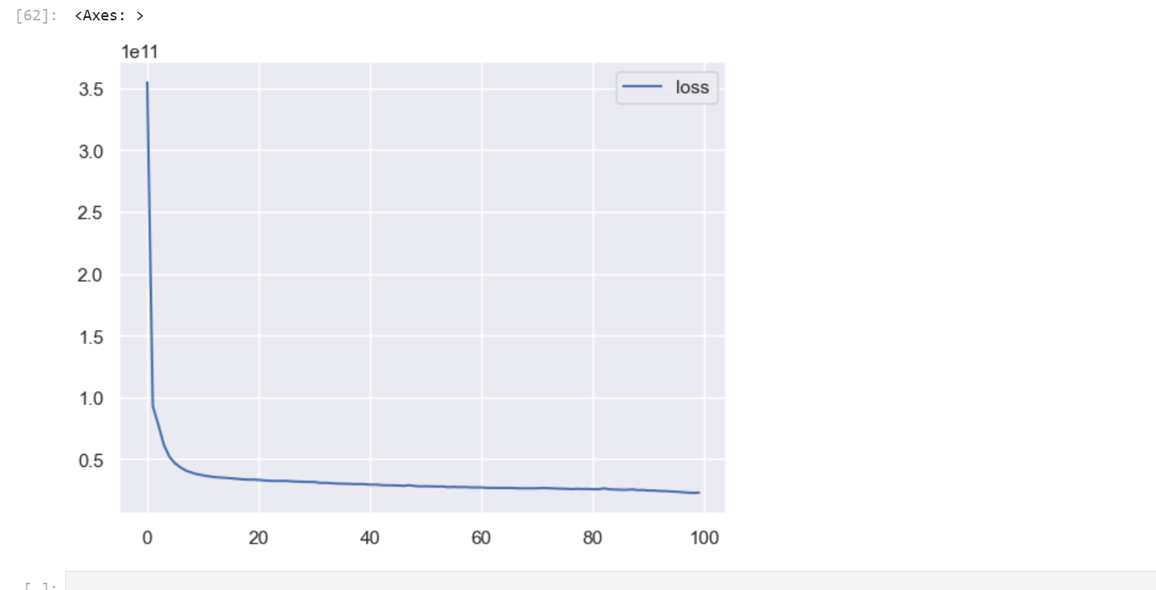

Task-4
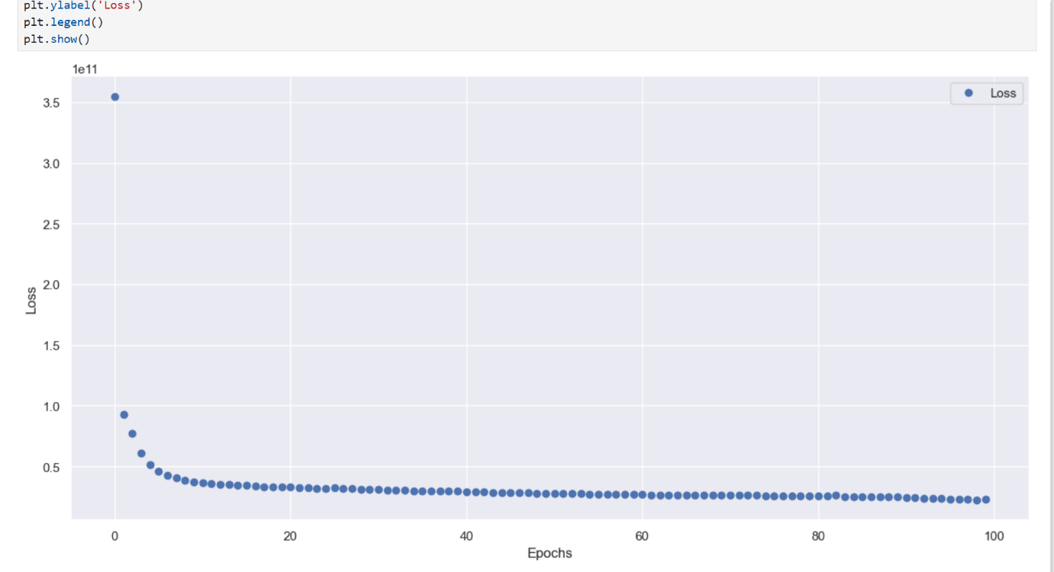

Lab 5

Lab 6

Lab 7

Lab 8

Lab 9

Lab 10

Lab 11

Lab 12

